**Exercise 1 - Inserting a Cover Page**  
  
To insert a cover page, follow these steps:  
  
1. Click the Insert Ribbon  
2. In the Pages Section, click Cover Page  
3. In the Cover Page gallery, select a design that you like  
  
The cover page will be inserted at the beginning of your document. The Drawing Tools Ribbon will open to allow you to customize the look of the cover page.  
  
**Exercise 2 - Saving a Cover Page to the Cover Page Gallery**  
  
If you would like to save your cover page for later use, follow these steps:  
  
1. Select your entire cover page in the Word window  
2. Click the Insert Ribbon  
3. In the Pages Section, click Cover Page  
4. Click Save Selection to Cover Page Gallery  
  
**Exercise 3 - Removing a Cover Page From Your Document**You can also remove a cover page if you want to insert a different one or if you decide you don't want a cover page at all:  
  
1. Click the Insert Ribbon  
2. In the Pages Section, click Cover Page  
3. Click Remove the Current Cover Page

**Exercise 4 -To format one section of text with Format Painter**

Follow these steps if you’re focusing on just one hunk of text:

1. Highlight the text that has the format you want to copy.
2. Click the Format Painter button in the Clipboard Group on the Home tab on the [Ribbon](http://www.dummies.com/how-to/content/how-to-format-text-with-the-word-2007-format-paint.html#glossary-Ribbon). It’s the button that looks like a paintbrush.
3. Click and drag the cursor over the text you want to copy the format to
4. Word formats the new text to look just like the already formatted text.

**Exercise 5 -To format multiple sections of text with Format Painter**

Format several chunks of text with these simple steps:

1. Highlight the text you want to use as your [template](http://www.dummies.com/how-to/content/how-to-format-text-with-the-word-2007-format-paint.html#glossary-template).
2. Double-click the Format Painter button.
3. The Format Painter now continuously formats text that you highlight.
4. When you're finished, click the Format Painter button again to turn the feature off.
5. You can also turn this feature off by pressing a key or double-clicking in the document.

**Exercise 6 -To insert a blank page in the document**

**[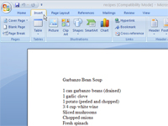](http://media.wiley.com/Lux/53/76553.image0.jpg?h=400&w=535)**

1. Click the Insert tab on the [Ribbon](http://www.dummies.com/how-to/content/how-to-insert-a-blank-page-in-word-2007.html#glossary-Ribbon).

**[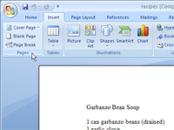](http://media.wiley.com/Lux/55/76555.image2.jpg?h=400&w=535)**

1. Find the Pages group.

The Pages group is the first group on the Ribbon, located next to the Tables group.

**[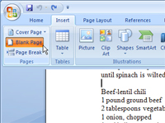](http://media.wiley.com/Lux/57/76557.image4.jpg?h=399&w=535)**

1. Click the Blank Page button.

This button inserts two hard page breaks into a document, which creates a blank sheet of paper.

Use this command only is you really need a blank page in the midst of a document — that is, only if you never plan on writing on that page. You can put graphics on the page or add a table, but writing on the page leads to formatting problems.

**Exercise 7 - Insert a table (using the templates)**

1. Click where you want to insert a table.
2. On the Insert tab, in the Tables group, click Table, point to Quick Tables, and then click the template that you want.

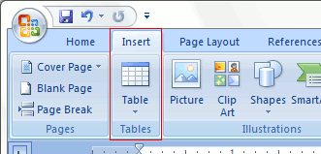

1. Replace the data in the template with the data that you want.

**Exercise 8 - Insert a table**

1. Click where you want to insert a table.
2. On the Insert tab, in the Tables group, click Table, and then, under Insert Table, drag to select the number of rows and columns that you want.



**Exercise 9 - Convert text to a table**

1. Select the text that you want to convert.
2. On the Insert tab, in the Tables group, click Table, and then click Convert Text to Table.



1. In the Convert Text to Table dialog box, under Separate text at, click the option for the separator character that you used in the text.

**Exercise 10 - Place a table inside another table**

1. You can insert a nested table by clicking in a cell and then using any of the methods to insert a table, or you can draw a table where you want the nested table.

**Exercise 11 - Insert clip art**

1. On the Insert tab, in the Illustrations group, click Clip Art.

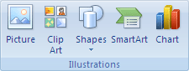

1. In the Clip Art task pane, in the Search for text box, type a word or phrase that describes the clip art that you want, or type in all or some of the file name of the clip art.
2. To narrow your search, do one or both of the following:
   1. To limit the search results to a specific collection of clip art, in the Search in box, click the arrow and select the collection you want to search.
   2. To limit the search results to clip art, click the arrow in the Results should be box and select the check box next to Clip Art.
3. In the Clip Art task pane, you can also search for photographs, movies, and sounds. To include any of those media types, select the check boxes next to them.
4. Click Go.
5. In the list of results, click the clip art to insert it.

**Exercise 12 - Insert a picture from a Web page**

1. Open the Microsoft Office Word 2007 document.
2. From the Web page, drag the picture that you want into the Word document.
3. Make sure the picture that you choose is not a link to another Web page. If you drag a picture that is linked, it will be inserted in your document as a link instead of an image.

**Exercise 13 - Insert a picture from a file**

1. Click where you want to insert the picture.
2. On the Insert tab, in the Illustrations group, click Picture.



1. Locate the picture that you want to insert.
2. Double-click the picture that you want to insert.

**Exercise 14 - Change an inline picture to a floating picture, and vice versa**

To make sure that the picture stays with text that references it — for example, a description above the picture, position the picture as an inline picture. If you add two paragraphs above the description, the picture will move down the page along with the description.

1. If the picture is not on a [drawing canvas](javascript:AppendPopup(this,'476871082_3')), select the picture. If the picture is on a drawing canvas, select the canvas.
2. Under Picture Tools, on the Format tab, in the Arrange group, click Position.

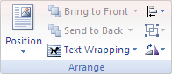

1. If you don't see Position, click Arrange, and then click Position.
2. Do one of the following:
   1. To change an [inline](javascript:AppendPopup(this,'533507688_4')) picture to a [floating](javascript:AppendPopup(this,'404831536_5')) picture, select the page position that you want.
   2. To change a floating picture to an inline picture, select In Line with Text.

**Exercise 15 - Insert a chart by embedding it in your document**

When you embed an Excel chart, information in the Word file doesn't change if you modify the source Excel file. Embedded objects become part of the Word file and, after they are inserted, they are no longer part of the source file.

Because the information is totally contained in one Word document, embedding is useful when you don't want the information to reflect changes in the source file, or when you don't want the document recipients to be concerned with updating the linked information.

1. In Word, click where you want to insert the chart.
2. On the Insert tab, in the Illustrations group, click Chart.
3. In the Insert Chart dialog box, click a chart, and then click OK.

Office Excel 2007 opens in a split window and displays sample data on a worksheet.

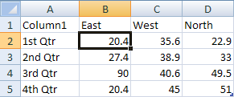

1. In Excel, replace the sample data by clicking a cell on the worksheet and then typing the data that you want.

You can also replace the sample axis labels in Column A and the legend entry name in Row 1.

 NOTE   After you update the worksheet, the chart in Word will be updated automatically with the new data.

1. In Excel, click the Microsoft Office ButtonButton image, and then click Save As.
2. In the Save As dialog box, in the Save in list, select the folder or drive that you want to save the worksheet to.

 TIP   To save the worksheet to a new folder, click Create New Folder Button image.

1. In the File name box, type a new name for the file.
2. Click Save.
3. In Excel, click the Microsoft Office ButtonButton image, and then click Close.

**Exercise 16 - Apply a predefined chart layout**

1. Click the chart that you want to format by using a predefined chart layout.

TIP   This displays the Chart Tools, adding the Design, Layout, and Format tabs.

1. On the Design tab, in the Chart Layouts group, click the chart layout that you want to use.

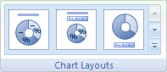

 NOTE   When the size of the Excel window is reduced, chart layouts will be available in the Quick Layout gallery in the Chart Layouts group.

**Exercise 17 - Add a chart title**

1. Click the chart to which you want to add a title.
2. This displays the Chart Tools, adding the Design, Layout, and Format tabs.
3. On the Layout tab, in the Labels group, click Chart Title.

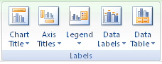

1. Click Centered Overlay Title or Above Chart.
2. In the Chart Title text box that appears in the chart, type the text that you want.

TIP   To insert a line break, click to place the pointer where you want to break the line, and then press ENTER.

1. To format the text, select it, and then click the formatting options that you want on the Mini toolbar.

 TIP   You can also use the formatting buttons on the Ribbon (Home tab, Font group). To format the whole title, you can right-click it, click Format Chart Title, and then select the formatting options that you want.

**Exercise 17 - Add axis titles**

1. Click the chart to which you want to add axis titles.
2. This displays the Chart Tools, adding the Design, Layout, and Format tabs.
3. On the Layout tab, in the Labels group, click Axis Titles.



1. Do any of the following:
2. To add a title to a primary horizontal (category) axis, click Primary Horizontal Axis Title, and then click the option that you want.

 TIP   If the chart has a secondary horizontal axis, you can also click Secondary Horizontal Axis Title.

1. To add a title to primary vertical (value) axis, click Primary Vertical Axis Title, and then click the option that you want.

 TIP   If the chart has a secondary vertical axis, you can also click Secondary Vertical Axis Title.

1. To add a title to a depth (series) axis, click Depth Axis Title, and then click the option that you want.

 NOTE   This option is only available when the selected chart is a true 3-D chart, such as a 3-D column chart.

1. In the Axis Title text box that appears in the chart, type the text that you want.

 TIP   To insert a line break, click to place the pointer where you want to break the line, and then press ENTER.

1. To format the text, select it, and then click the formatting options that you want on the Mini toolbar.

 TIP   You can also use the formatting buttons on the Ribbon (Home tab, Font group). To format the whole title, you can right-click it, click Format Axis Title , and then select the formatting options that you want.

**Exercise 18 - Add data labels**

1. On a chart, do one of the following:

* To add a data label to all data points of all data series, click the chart area.
* To add a data label to all data points of a data series, click anywhere in the data series that you want to label.
* To add a data label to a single data point in a data series, click the data series that contains the data point that you want to label, and then click the data point that you want to label.

This displays the Chart Tools, adding the Design, Layout, and Format tabs.

1. On the Layout tab, in the Labels group, click Data Labels, and then click the display option that you want.



**Exercise 19 -** **Create new section breaks and applying header , footer:**1.  Select the place on the document that the user desires to place a section break.  
  
2.  Click the Page Layout tab. In the Page Setup section, Click the button labeled Breaks. Choose the desired break style to insert the section break. Repeat this process until the desired number of sections has been reached. The headers must be in different sections, not just on different pages, for these instructions to work. Be sure to choose one of the options under Section Breaks under the Breaks button. 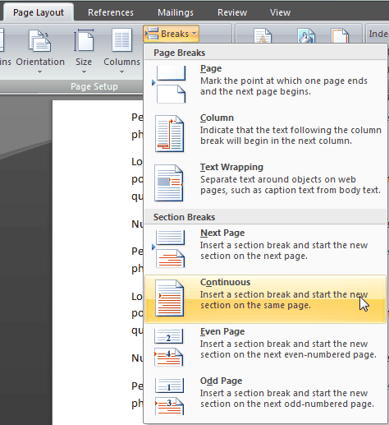Set these sections to use different headers and footers:

1. Click in the section for which it is desired to create a different header or footer.
2. On the Insert tab, in the Header & Footer group, click Header or Footer.  
   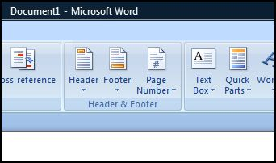
3. Click Edit Header or Edit Footer.  
   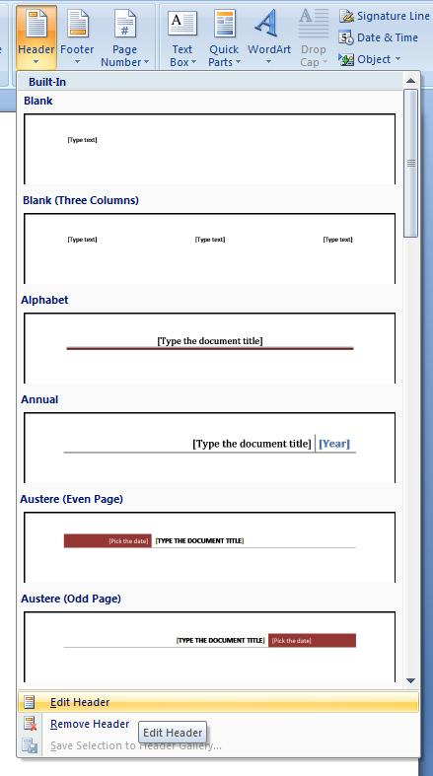
4. Select the header or footer that is located in the newly created section.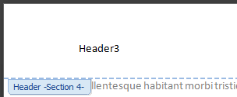
5. On the Headers & Footers tab, and in the Navigation group, click Link to Previous to break the connection between the header and footer in the new section and the previous section. Change the existing header or footer, or create a new header or footer for this section.  
   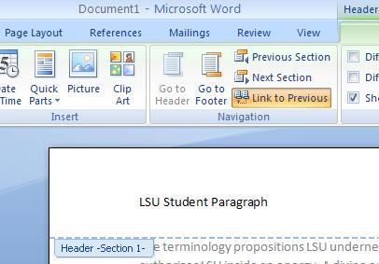
6. The new section will now display a different header or footer than the rest of the document.  
   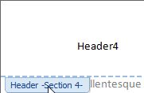
7. Select Remove Content Control to get the header to change in different sections.